A Project Report

On

**Software Development: Optimization Techniques Algorithms**

BY

**Ajith**

**Krishnachaitanya**

**Deekshith**

**Amruth**

**Rishi**

**Priyananda**

**Naveen**

Under the supervision of

**P.Bhanukiran**

**SUBMITTED IN PARTIAL FULLFILLMENT OF THE REQUIREMENTS OF**

**PR 301: PROJECT TYPE COURSE**

cid:image003.png@01D6594A.2604D070

**ECOLE CENTRALE SCHOOL OF ENGINEERING**

**HYDERABAD**

**(June , 2023**)

ACKNOWLEDGMENTS

We want to express our deepest gratitude and appreciation to everyone who has contributed to the successful completion of our project report, held at Mahindra University, under the guidance of Professor Bhanukiran. Their invaluable support and encouragement have played a vital role in shaping this project and enriching our learning experience.

First and foremost, We extend our heartfelt thanks to Professor Bhanukiran for his unwavering guidance, expertise, and constant support throughout the project. His profound knowledge and insightful suggestions have been instrumental in shaping our research.

We are indebted to the faculty members and the staff of Mahindra University for their dedication and commitment to nurturing an environment conducive to learning and research. Their expertise and willingness to share knowledge have significantly contributed to our understanding of the subject matter.

Additionally, we would like to acknowledge the support and encouragement of our friends who have been there with us throughout this journey. Their camaraderie, discussions, and collaborative efforts have enriched our experience and made the process enjoyable.

In conclusion, We would like to express our gratitude to all the individuals mentioned above and anyone who has directly or indirectly contributed to the successful completion of this project. Your support has been invaluable, and we are truly grateful for the opportunity to work on this project at Mahindra University under the guidance of Professor Bhanukiran.

cid:image003.png@01D6594A.2604D070

**Ecole Centrale School of Engineering**

**Hyderabad**

Certificate

This is to certify that the project report entitled **“Software Development: Optimization Techniques-Algorithms”** submitted by Mr.Ajith(SE20UCAM002),Mr.Krishnachaitainya(SE20UCAM019),Mr.Deekshith(SE20UCAM011),Mr.Naveen(SE20UECE053), Mr.Amruth(SE20UCSE063), Mr.Rishi(SE20UCSE139) and Ms.Priyananda(SE20UEEE031) partial fulfillment of the requirements of the course PR 3201, embodies the work done by him/her under my supervision and guidance.

**(Mr.P.Bhanukiran & Signature)**

Ecole Centrale School of Engineering, Hyderabad.

Date:

ABSTRACT

The project "Software Development: Optimization Techniques Algorithms" focuses on the development of a software repository containing a collection of optimization algorithms commonly discussed in undergraduate-level Optimization Techniques courses. The repository aims to cover a broad spectrum of techniques, ranging from basic linear programming to advanced multidimensional multi objective optimization problems. The chosen programming language for implementation is Python.

The repository will serve as a valuable reference for students, researchers, and practitioners in the field of optimization. It will facilitate the understanding and implementation of optimization algorithms, allowing users to experiment, compare, and analyze their performance on different problem domains. The use of Python as the programming language ensures accessibility and ease of use for a wide range of users.

In conclusion, this project aims to create a repository of optimization algorithms implemented in Python, providing a valuable resource for individuals interested in optimization techniques. Through practical code examples and visualization capabilities, users will be able to explore and apply these algorithms to various optimization problems. The project offers an enriching learning experience for participating students, while also contributing to the advancement and accessibility of optimization knowledge and tools.

CONTENTS

Title page………………………………………………………… …….1

Acknowledgement.……………………………………………………...2

Certificate…………………………………………………………….....3

Abstract………………………………………………………………....4

1.Calculus of variation..………………………………….……… ….....6

2.Neural networks…………………………………………….………..,9

3.Calculus of variation with neural networks……………………………………………………………….10

4.Optimization of neural network problems……………………………………………………………….11

5.Optimization using calculus of variation……………………………14

6.Variational Autoencoder….…………………………………………16

7.Code in python………………………………………………………17

8.Working of the code…………………………………………………22

9.References…………………………………………………………...26

CALCULUS OF VARIATION

The Calculus of Variations is a branch of mathematics that deals with the study of functions and functionals. It focuses on finding functions that optimize or extremize certain quantities, often expressed as functionals. These functionals are mappings that assign a real number to each function. The goal of the Calculus of Variations is to determine the function or functions that minimize or maximize these functionals.

In the Calculus of Variations, the basic idea is to consider a family of functions and examine how the value of a given functional changes as we vary these functions. The functional could be an integral, involving the function and its derivatives, or it could be expressed in terms of other mathematical operations applied to the function.

A fundamental concept in the Calculus of Variations is the principle of extremal. An extremal is a function that makes the functional either a minimum or a maximum. The extremals can be thought of as critical points of the functional. To find these extremals, the Euler-Lagrange equation is employed.

The Euler-Lagrange equation is a necessary condition for a function to be an extremal of a functional. It is derived by considering variations of the functional with respect to the function under consideration. The equation involves taking the derivative of the functional with respect to the function and setting it equal to zero. Solving the Euler-Lagrange equation yields the candidate functions that extremize the functional.

The Calculus of Variations also encompasses variational principles and variational problems. Variational principles are mathematical statements that express relationships between a functional and its extremals. For example, the principle of least action in physics states that the actual path taken by a particle between two points is the one that minimizes the action functional.

Variational problems involve finding functions that satisfy certain constraints or optimize a certain quantity. These problems can include finding the curve of minimal length between two points or determining the shape of a surface with minimal surface area. The Calculus of Variations provides tools and techniques to solve these variational problems.

The applications of the Calculus of Variations are diverse and span various disciplines. It is used in physics to describe the motion of particles and fields, in engineering to optimize designs and control systems, in economics to model and analyze optimization problems, and in many other fields.

In summary, the Calculus of Variations is a mathematical framework that deals with finding functions that minimize or maximize functionals. It involves the study of extremals, the derivation of the Euler-Lagrange equation, and the application of variational principles and techniques to solve variational problems. It is a powerful tool for optimization and has broad applications in science, engineering, economics, and other fields.

The calculus of variations is a mathematical field that deals with optimizing functional, which are functions that map a set of functions to real numbers. It involves finding the function(s) that minimize or maximize the value of a functional. In the context of neural networks, the calculus of variations can be used to optimize various aspects of the network's performance.

One common application of the calculus of variations in neural networks is in the optimization of loss functions. Loss functions quantify the discrepancy between the predicted output of a neural network and the desired output. By minimizing the loss function, the neural network learns to make better predictions.

The process of optimizing the loss function typically involves adjusting the weights and biases of the network using optimization algorithms such as gradient descent. The calculus of variations comes into play when computing the gradients, which indicate the direction and magnitude of the adjustments to be made to the network parameters.

In more advanced scenarios, the calculus of variations can also be used to optimize the architecture of the neural network itself. This involves determining the number of layers, the number of neurons in each layer, and other architectural choices. The goal is to find the network configuration that minimizes the loss function and maximizes the network's performance on a given task.

Additionally, the calculus of variations can be used to optimize regularization techniques in neural networks. Regularization is a method to prevent over-fitting and improve generalization by adding extra terms to the loss function. These terms typically penalize complex models or large weights. By applying the calculus of variations, one can find the optimal values for the regularization parameters to strike a balance between model complexity and accuracy.

The calculus of variations provides a mathematical framework for optimizing different aspects of neural networks, including loss functions, network architecture, and regularization techniques. It allows researchers and practitioners to leverage the principles of optimization to improve the performance and generalization capabilities of neural networks.

NEURAL NETWORKS

Neural networks are a class of machine learning models inspired by the structure and function of biological brains. They are computational models composed of interconnected nodes, called artificial neurons or simply "neurons." These neurons are organized into layers, and information flows through the network from the input layer, through one or more hidden layers, to the output layer.

Each neuron in a neural network receives input signals, performs a computation, and produces an output. The input to a neuron is a weighted sum of the outputs from the neurons in the previous layer, which is then passed through an activation function. The activation function introduces non-linearity into the model and helps the network learn complex relationships between inputs and outputs.

The process of training a neural network involves adjusting the weights and biases associated with the connections between neurons. This is typically done using a technique called back propagation, which involves propagating the error or the difference between the predicted output and the desired output, backward through the network and updating the weights accordingly. This iterative process continues until the network's performance reaches a satisfactory level.

Neural networks can be used for various machine learning tasks, including classification, regression, clustering, and pattern recognition. They have been successfully applied in many domains, such as computer vision, natural language processing, speech recognition, and recommendation systems.

There are different types of neural networks, including feed forward neural networks, convolution neural networks (CNN s), recurrent neural networks (RNN), and more advanced architectures like long short-term memory (LSTM) networks and generative adversarial networks (GAN s). Each type of network is designed to handle specific types of data and learning tasks.

Overall, neural networks have proven to be powerful tools for solving complex problems and have significantly contributed to advancements in artificial intelligence and machine learning.

CALCULUS OF VARIATION WITH NEURAL NETWORKS

The calculus of variations and neural networks are both mathematical frameworks that have connections and can be applied to various problems in optimization and machine learning. While they have distinct origins and methodologies, there are some interlinks between the two.

The calculus of variations deals with finding the extreme (minimum or maximum) of a functional, which is a function of a function. It involves optimizing a certain quantity, typically expressed as an integral, over a set of functions. This field of mathematics is concerned with finding the function that minimizes or maximizes the integral.

On the other hand, neural networks are computational models inspired by the structure and function of the human brain. They consist of interconnected nodes (neurons) organized into layers, and they learn from data to approximate complex mappings between inputs and outputs. Neural networks are trained using optimization techniques, such as gradient descent, to minimize a loss function that measures the discrepancy between the predicted output and the true output.

The interlink between the calculus of variations and neural networks arises from the optimization aspect. Neural networks can be seen as a differentiable mapping from inputs to outputs, and the training process involves optimizing the network's parameters to minimize the discrepancy between predicted and true outputs. This optimization can be formulated as a calculus of variations problem, where the goal is to find the function (the neural network) that minimizes a certain functional (the loss function).

More specifically, the connection can be made through the concept of the Euler-Lagrange equation, which is a fundamental equation in the calculus of variations. The Euler-Lagrange equation describes necessary conditions for a function to be an extreme of a functional. By formulating the neural network training problem as a functional optimization, one can use the Euler-Lagrange equation to derive update rules for the network's parameters during the training process.

Additionally, techniques from the calculus of variations, such as variational methods and optimization algorithms, can be employed to analyze and improve the training of neural networks. These techniques can help in designing more efficient training algorithms, regularization methods, and understanding the convergence properties of neural network optimization.

In summary, the interlink between the calculus of variations and neural networks lies in the optimization aspect of training neural networks, where concepts and techniques from the calculus of variations can be used to analyze and improve the training process.

OPTIMIZATION OF NEURAL NETWORK PROBLEMS

Using the calculus of variations to optimize neural network problems involves formulating the training process as an optimization problem and applying variational methods to find the optimal solutions. Here's a general outline of how this can be done:

1. Define the Objective Function: Start by defining an objective function that measures the discrepancy between the predicted output of the neural network and the true output (often referred to as the loss function). This function quantifies the error or mismatch between the network's predictions and the desired outputs.

2. Formulate the Functional: The objective function can be considered a functional, which is a function that takes a function (the neural network parameters) as input and produces a scalar value (the loss) as output. This functional is defined over the space of possible neural network parameters.

3. Apply the Euler-Lagrange Equation: The next step is to apply the Euler-Lagrange equation, a key tool in the calculus of variations. The Euler-Lagrange equation gives necessary conditions for a function to be an extremum of a functional. By applying this equation to the functional defined in step 2, you can derive equations that determine the optimal values of the neural network parameters.

4. Solve the Optimization Problem: The derived equations from the Euler-Lagrange equation form a set of differential equations or optimization conditions. Solving these equations or conditions involves finding the optimal values for the network parameters that minimize the objective function. Various techniques can be employed for solving these equations, such as numerical methods, gradient-based optimization algorithms (e.g., stochastic gradient descent), or advanced optimization techniques specific to the neural network architecture.

5. Iterate and Update Parameters: Once the optimization problem is solved and the optimal values for the network parameters are obtained, you can update the parameters accordingly. This process involves iteratively adjusting the network's parameters based on the optimization algorithm used until convergence is reached or a stopping criterion is met.

It's important to note that directly applying the calculus of variations to optimize neural networks can be computationally challenging, especially for complex network architectures. In practice, variations of gradient-based optimization algorithms, such as stochastic gradient descent (SGD) and its variants (e.g., Adam, RMS prop), are widely used for training neural networks due to their efficiency and scalability. These algorithms approximate the optimal solution by iteratively updating the parameters based on the gradients of the objective function with respect to the parameters.

In summary, the calculus of variations can provide a theoretical framework for understanding and formulating the optimization problem in neural network training. However, practical implementation often involves leveraging gradient-based optimization algorithms to approximate the optimal solutions efficiently.

## OPTIMIZATION ALGORITHEMS :-

There are several optimization algorithms commonly used in training neural networks. Each algorithm has its characteristics and advantages, and the choice depends on factors such as the problem domain, network architecture, and available computational resources. Here are some popular optimization algorithms:

Gradient Descent (GD): Gradient descent is the fundamental optimization algorithm used for training neural networks. It iteratively updates the network's parameters in the direction of steepest descent of the loss function. Variations of gradient descent include:

a. Batch Gradient Descent (BGD): Updates the parameters using the gradients computed on the entire training data set. It can be computationally expensive for large datasets.

b. Stochastic Gradient Descent (SGD): Updates the parameters using the gradients computed on a single training sample. It provides faster updates but can have high variance.

c. Mini-Batch Gradient Descent: Updates the parameters using the gradients computed on a small batch of training samples. It balances the advantages of BGD and SGD, providing a trade-off between computation and noise in the updates.

Momentum: Momentum is an extension of gradient descent that accelerates convergence by adding a fraction of the previous update to the current update step. It helps to overcome local minima, plateaus, and noisy gradients.

Nesterov Accelerated Gradient (NAG): NAG is an enhancement of momentum that reduces the overshooting effect. It calculates the gradient not at the current position but at an estimated future position based on the momentum.

Adaptive Moment Estimation (Adam): Adam combines the benefits of adaptive learning rates and momentum. It maintains moving averages of past gradients and squared gradients, adapting the learning rate for each parameter individually. Adam has become popular due to its effectiveness in a wide range of scenarios.

Root Mean Square Propagation (RMSprop): RMSprop is another adaptive learning rate optimization algorithm. It divides the learning rate by a running average of the magnitudes of past gradients. It helps to alleviate the diminishing learning rate problem in deep neural networks.

AdaGrad: AdaGrad adapts the learning rate for each parameter based on the historical gradient information. It assigns larger learning rates for infrequent features and smaller learning rates for frequent features, making it suitable for sparse domains.

AdaDelta: AdaDelta is an extension of AdaGrad that aims to address its monotonically decreasing learning rate problem. It replaces the historical gradient information with a moving average of past squared updates.

Adaptive Learning Rate (Adagrad + RMSprop): This technique combines Adagrad and RMSprop to leverage their respective advantages. It adapts the learning rate like Adagrad but also includes the exponential decay of past squared gradients like RMSprop.

Adamax: Adamax is a variant of Adam that uses the infinity norm (maximum value) of the past gradients instead of the L2 norm. It is claimed to be less sensitive to large gradients and can be useful in certain scenarios.

Nadam: Nadam combines the benefits of NAG and Adam. It incorporates NAG into the Adam algorithm, leading to improved convergence rates.

These are just a few examples of optimization algorithms used in neural networks. It's important to experiment with different algorithms and tune their hyper parameters to find the best optimization strategy for a given task.

OPTIMIZATION USING CALCULUS OF VARIABLES

The calculus of variations is a mathematical field that deals with optimizing functionals, which are functions that map a space of functions to the real numbers. While it is not directly used in traditional neural network optimization, there are some connections and applications of calculus of variations techniques in the context of neural networks. Here are a few examples:

Variational Auto encoders (VAE s): VAE s are generative models that combine deep learning with the principles of variational inference. They are trained by maximizing a lower bound on the log-likelihood of the data. The optimization problem involves finding the optimal encoder and decoder networks that minimize the reconstruction loss while maximizing a divergence term that encourages the learned latent space to follow a prior distribution. The calculus of variations is used to derive the necessary optimization updates for the encoder and decoder networks.

Optimal Control for Dynamical Systems: In some applications, neural networks are used as controllers for dynamical systems. The goal is to find the optimal control policy that minimizes a cost functional subject to system dynamics and constraints. The calculus of variations provides techniques like the Pontragin's maximum principle or Hamilton-Jacobi-Bellman equations, which help in formulating and solving these optimal control problems.

Physics-Informed Neural Networks (PINN s): PINN s combine neural networks with the principles of physics-based modeling. They aim to learn solutions to partial differential equations (PDE s) by minimizing a loss function that includes both data-fitting terms and physics-based regularization terms. The regularization terms are derived using the calculus of variations and the governing PDE s. PINN s can be used for tasks such as solving inverse problems, parameter estimation, or uncertainty quantification.

Functional Optimization for Network Architectures: The architecture search problem involves finding the optimal neural network architecture for a given task. The calculus of variations can be used to formulate and solve optimization problems to find network architectures that optimize certain performance metrics, such as accuracy, complexity, or resource utilization. By treating the architecture as a functional and optimizing it using variational principles, techniques from calculus of variations can be leveraged.

It's important to note that while the calculus of variations has some applications in the context of neural networks, the primary optimization techniques used in neural network training typically involve gradient-based optimization algorithms like gradient descent and its variants. These techniques, which focus on optimizing the parameters of the network to minimize a loss function, have been more widely adopted in the field of deep learning.

Let us look at some algorithms more precisely

One neural network algorithm that incorporates calculus of variations is the Variational Auto encoder (VAE). The VAE is a generative model that learns a latent representation of the data and can generate new samples from this learned representation. It is based on the principles of Bayesian inference and variational inference, which involve optimizing a lower bound on the log-likelihood of the data.

In the VAE, the latent space is typically assumed to follow a simple distribution, such as a multivariate Gaussian. The goal is to learn the parameters of this latent distribution that maximize the likelihood of the observed data. To achieve this, the VAE employs an encoder network that maps input data to the latent space and a decoder network that reconstructs the data from the latent space.

The key idea behind the VAE is to introduce a regularizing term in the optimization objective that encourages the learned latent distribution to match the assumed prior distribution. This regularization term is derived using the calculus of variations and is known as the Kullback-Leibler (KL) divergence. The KL divergence measures the difference between the learned latent distribution and the prior distribution.

The optimization objective of the VAE can be formulated as a variational lower bound on the log-likelihood of the data, which is maximized during training. The lower bound is derived using the evidence lower bound (ELBO) principle, and it involves minimizing the reconstruction loss (typically a pixel-wise reconstruction loss for image data) and the KL divergence term.

By optimizing the variational lower bound, the VAE learns to encode the input data into a lower-dimensional latent space and reconstructs the data from this latent space. The VAE can then generate new samples by sampling from the learned latent distribution and decoding them using the decoder network.

In summary, the VAE is a neural network algorithm that combines the principles of variational inference and the calculus of variations to learn a generative model of data. It utilizes the KL divergence term as a regularizing term in the optimization objective to encourage the learned latent distribution to match a specified prior distribution.

**Variational Auto encoder (VAE):-**The Variational Autoencoder (VAE) is a type of generative model that combines ideas from deep learning and variational inference. It is used to learn a low-dimensional representation of input data and generate new samples from that representation. VAEs are particularly effective for modeling complex high-dimensional data, such as images or text.

The VAE consists of an encoder network, a decoder network, and a latent space. The encoder network takes in the input data and maps it to the parameters of a probability distribution in the latent space. The decoder network takes samples from the latent space and reconstructs the original data.

The key innovation of VAEs lies in the use of variational inference to learn the latent representation. Instead of directly optimizing the parameters of the encoder and decoder networks, VAEs optimize a lower bound on the log-likelihood of the data, which is derived using the evidence lower bound (ELBO) principle.

The ELBO is a trade-off between the reconstruction accuracy and the divergence between the learned latent distribution and a predefined prior distribution. This divergence term, typically the Kullback-Leibler (KL) divergence, acts as a regularization term and encourages the learned latent distribution to match the prior distribution.

During training, VAEs minimize the negative ELBO by back propagation and stochastic gradient descent. This involves sampling from the learned latent distribution, feeding the samples through the decoder, and comparing the reconstructed data to the original input.

Once trained, VAEs can generate new samples by sampling from the prior distribution and passing the samples through the decoder network. The decoder acts as a generator, mapping latent space samples to meaningful data points in the input space.

VAEs have several advantages, including their ability to learn meaningful latent representations and their generative capabilities. By exploring different regions of the latent space, VAEs can generate diverse and novel samples. They have been successfully applied to tasks such as image generation, anomaly detection, and data compression.

Overall, the Variational Auto encoder is a powerful neural network algorithm that combines deep learning and variational inference to learn latent representations and generate new samples from them.

Both Adam and AdaGrad are popular adaptive optimization algorithms used in training neural networks. While they share some similarities, they have distinct characteristics and update rules. Let's explore each algorithm:

AdaGrad (Adaptive Gradient):

AdaGrad adapts the learning rate for each parameter based on the historical gradient information.

It maintains a separate learning rate for each parameter, which is inversely proportional to the cumulative sum of the squared gradients for that parameter.

The update rule for AdaGrad can be expressed as:

learning_rate = initial_learning_rate / sqrt(cumulative_sum_of_squared_gradients + epsilon)

parameter += -learning_rate * gradient

AdaGrad performs well in sparse domains, where some features have a low frequency. It automatically reduces the learning rate for parameters associated with frequently occurring features, allowing slower updates for these parameters.

Adam (Adaptive Moment Estimation):

Adam combines the concepts of momentum and adaptive learning rates.

It calculates adaptive learning rates for each parameter similar to AdaGrad but additionally includes momentum-like terms.

Adam maintains an exponentially decaying average of past gradients (first moment) and squared gradients (second moment) for each parameter.

The update rule for Adam can be expressed as:

m = beta1 * m + (1 - beta1) * gradient

v = beta2 * v + (1 - beta2) * (gradient ** 2)

learning_rate = initial_learning_rate * sqrt(1 - beta2^t) / (1 - beta1^t)

parameter += -learning_rate * m / (sqrt(v) + epsilon)

Here, m and v represent the first and second moment estimates, respectively, and t is the time step.

Adam combines the benefits of adaptive learning rates (AdaGrad) and momentum. It performs well in practice and has become a widely used optimization algorithm.

Both AdaGrad and Adam have their advantages and are suitable for different scenarios. AdaGrad is particularly useful in sparse domains, while Adam is a versatile choice for various deep learning tasks. It's worth noting that there are many other optimization algorithms available, and the choice depends on the specific problem and empirical performance on the

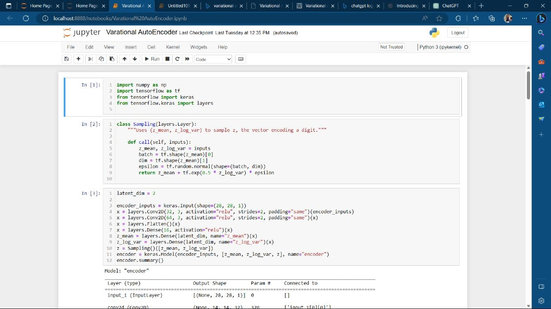

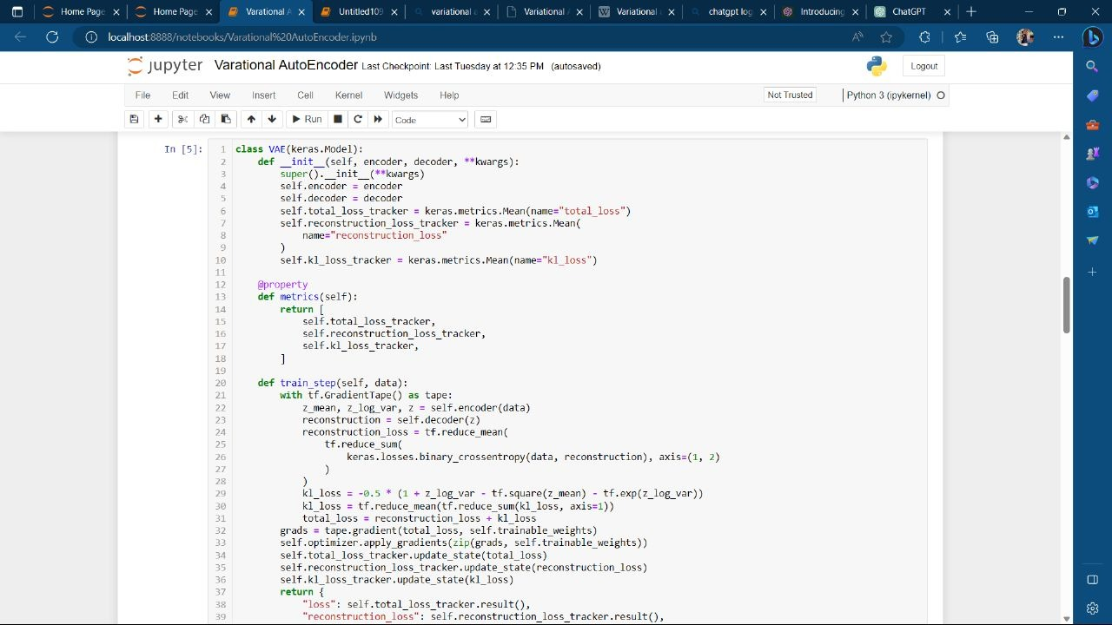

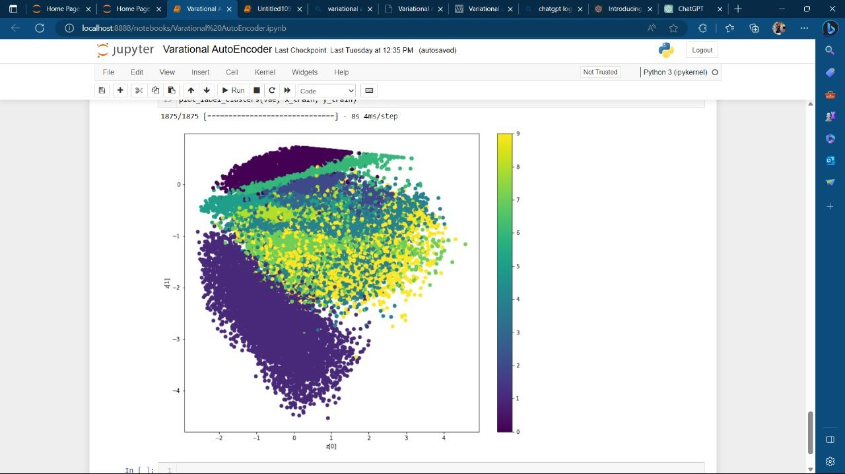

WORKING OF THE CODE

The code implements a Variational Autoencoder (VAE) using TensorFlow and Keras. Here is a step-by-step explanation of how the code works:

1. Importing the necessary libraries: The code imports numpy, TensorFlow, and Keras modules and layers. These libraries provide the required functionality for building and training the VAE model.

2. Defining the Sampling layer: The `Sampling` class is defined as a custom layer. It takes the mean and log variance of the latent space as inputs and uses them to sample a latent vector using the reparameterization trick. The sampled vector is obtained by adding random noise to the mean and multiplying it by the exponential of half the log variance.

3. Building the encoder: The code defines the architecture of the encoder neural network. It starts with an input layer that expects images of size 28x28 with one channel (grayscale). The input is then passed through convolutional layers with a stride of 2 to reduce the spatial dimensions. The convolutional layers are followed by a flatten layer to convert the output into a 1D vector. Next, a dense layer with ReLU activation is applied to further encode the input. The final layers are two dense layers that output the mean and log variance of the latent space, respectively.

4. Building the decoder: The code defines the architecture of the decoder neural network. It starts with an input layer that expects the sampled latent vector. The input is passed through a dense layer with ReLU activation to expand it into a higher-dimensional space. Then, a reshape layer is used to convert the 1D vector into a 3D tensor. Transposed convolutional layers with ReLU activation and a stride of 2 are applied to upsample the tensor and increase the spatial dimensions. The final layer is a transposed convolutional layer with sigmoid activation, which generates the reconstructed images.

5. Defining the VAE model: The `VAE` class is defined as a subclass of the Keras `Model` class. It takes the encoder and decoder as inputs. The `VAE` class overrides the `train_step` method to define the training procedure for the VAE. Within the `train_step` method, the forward pass is performed using the encoder and decoder, and the reconstruction loss and KL divergence loss are calculated. The total loss is the sum of the reconstruction loss and KL divergence loss. The gradients of the total loss with respect to the trainable weights are computed using automatic differentiation. These gradients are then used to update the model's weights using the specified optimizer.

6. Preparing the MNIST dataset: The code loads the MNIST dataset using the `keras.datasets.mnist.load_data()` function. The dataset is split into training and test sets, and the pixel values are normalized to the range [0, 1] by dividing by 255. The training and test sets are combined into a single numpy array.

7. Compiling and training the VAE: The VAE model is compiled using the Adam optimizer, which is a popular optimization algorithm for neural networks. The `fit` method is called to train the VAE on the MNIST dataset. The number of epochs and batch size are specified as parameters.

8. Visualizing the latent space: Two functions are defined to visualize the learned latent space: `plot_latent_space` and `plot_label_clusters`.

9. Plotting the latent space: The `plot_latent_space` function generates a grid of digits by sampling from the latent space and decoding them using the decoder. It creates a 2D plot where the x-axis represents the first dimension of the latent space and the y-axis represents the second dimension. Each point in the plot corresponds to a generated digit based on its latent space coordinates.

10. Plotting

the label clusters: The `plot_label_clusters` function uses the encoder to obtain the latent space representations of the input dat…

what is the motive of the code

The motive of the code is to demonstrate the implementation of a Variational Autoencoder (VAE) using TensorFlow and Keras. A VAE is a type of generative model that can learn to encode high-dimensional data into a lower-dimensional latent space and decode it back to reconstruct the original data. The VAE is trained using a combination of a reconstruction loss, which encourages the model to reconstruct the input data accurately, and a KL divergence loss, which helps to regularize the latent space and encourage it to follow a prior distribution (usually a standard normal distribution).

The code specifically focuses on using a VAE to encode and decode images from the MNIST dataset, which consists of handwritten digits. The VAE learns to encode the images into a lower-dimensional latent space and reconstruct them from the latent representations. The code provides visualizations of the learned latent space, allowing us to visualize the distribution of digit representations and explore the continuous structure of the latent space.

The ultimate motive of the code is to showcase the capabilities of VAEs in learning meaningful representations of complex data and generating new samples from the learned latent space. By training the VAE on the MNIST dataset and visualizing the latent space, the code demonstrates how the VAE can capture and generate realistic digit images. This serves as an example of how VAEs can be used for tasks such as image generation, anomaly detection, and data compression.

how calculus of varations used in this code

The Variational Autoencoder (VAE) architecture incorporates concepts from the field of calculus of variations, specifically in the calculation of the Kullback-Leibler (KL) divergence loss term.

In the VAE framework, we aim to maximize the evidence lower bound (ELBO) objective, which consists of two terms: the reconstruction loss and the KL divergence loss. The KL divergence measures the difference between the distribution of the learned latent space and a prior distribution, typically a standard normal distribution.

To calculate the KL divergence loss, the code uses the following formula:

python

kl_loss = -0.5 * (1 + z_log_var - tf.square(z_mean) - tf.exp(z_log_var))

kl_loss = tf.reduce_mean(tf.reduce_sum(kl_loss, axis=1))

Let's break this down:

1. `kl_loss` is calculated based on the mean (`z_mean`) and log variance (`z_log_var`) of the latent space.

2. The formula `-0.5 * (1 + z_log_var - tf.square(z_mean) - tf.exp(z_log_var))` computes the element-wise KL divergence loss for each sample in the batch.

3. `tf.reduce_sum(kl_loss, axis=1)` calculates the sum of the KL divergence loss for each sample in the batch.

4. `tf.reduce_mean` takes the mean of the summed KL divergence losses across the batch, resulting in a single scalar value.

The KL divergence loss penalizes the deviation of the learned latent space from the prior distribution. Minimizing this loss helps to encourage the latent space to adhere to the prior distribution and enables better generalization and regularization.

While calculus of variations is not explicitly used in other parts of the code, the overall VAE architecture and the training procedure are derived from probabilistic modeling principles, which are grounded in concepts from calculus of variations and information theory. The VAE framework leverages variational inference and optimization techniques to learn meaningful latent representations and perform generative modeling.

References

1."Introduction to optimization” by Pablo pedregal.

1. "Introduction to Algorithms" by Thomas H. Cormen, Charles E. Leiserson, Ronald L. Rivest, and Clifford Stein.

4. "Optimization Methods for Large-Scale Systems" by William W. Hager and Hongchao Zhang.

5. "Numerical Optimization" by Jorge Nocedal and Stephen J. Wright.